**Practical Exercise - Walkthrough**

**Change the variable names to meaningful ones:**

* *H* could be for example changed to *Name*.
* *Dd*should be *PhoneNumber*.
* *Dd1*would be better called *Email*.
* If the value of the **ArrayRow** property from the **Add Data Row** activity has not been automatically updated, then do it manually.

Put the recording part in a separate workflow:

* This is easiest done by rightclicking the **Attach Window** container and choosing the **Extract as Workflow** option.
* Note that the *Name*, *PhoneNumber*and *Email*variables have been automatically created as Arguments of type **Out** for the new generated workflow as this new file does not receive any inputs, but is supposed to return back to the **Main** workflow the data fields extracted from the web.
* In the main workflow, the sequence has been replaced by an **Invoke Workflow** activity which targets the new workflow.
  + Click **Import Arguments** and in the **Value** field for each argument, enter the corresponding variable.

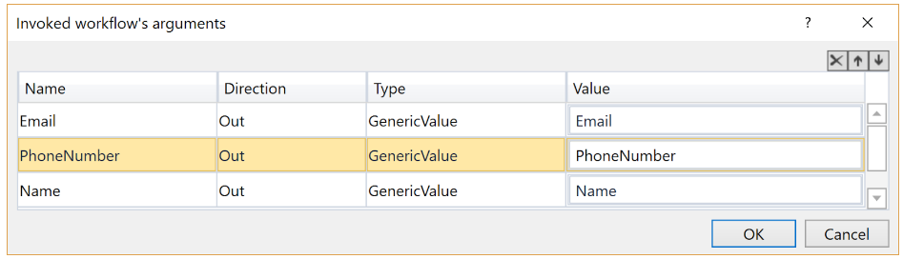

Create a loop in the main workflow and invoke the newly created workflow inside of it. Since we want to execute it 5 times, an appropriate choice would be a **While** or**Do While** loop.

* after you drag the **While** activity to the workflow, using the **Variables Panel**, create an **Int32** variable with 1 as the default value, so we can use it as a counter.
* use the previously created variable to set a **Condition** for the **While** activity, such as *counter < 6.*
* you can drag the previously generated **Invoke Workflow** activity to the project.
* The **Add Data Row** activity should be moved to the new loop, as we want to execute it 5 times, and placed after the**Invoke Workflow** activity.
* Don’t forget to increment the counter at the end of the loop, so you can keep track of how many rows have been added to the Data Table.
  + Use an **Assign** activity and setting the value of the counter to its own (previous)+1.

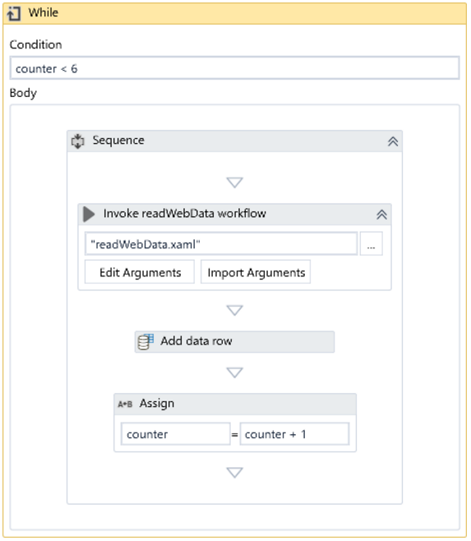

However, the**Build Data Table**activity should be executed only once, so we have to keep it before the **While**loop.

Similarly, we want to write the resulted table with 5 rows to Excel only once, after collecting all the data. As a result, we should place the **Write Range** activity (and its **Excel Application Scope** container) after the **While**loop.

Additionally, we have to write all the people's names in the same file, called people.xlsx. To do this, type the name of this file in the **Workbook Path** property of the **Excel Application Scope** activity.

* preferably the name would be kept in a String variable to be easily changed.

As the filename doesn’t depend on the actual person's name and we don’t need the *Name*, *PhoneNumber*and *Email*variables outside the Recording Sequence, we can restrict their scope to the Sequence inside the **While** loop.